- Pydantic:
- definition:
Pydantic is a Python library that helps us in defining and validating data models easily. When we build applications, that handle user input or data from various sources, it is important to make sure that the data is valid and consistent. If we do not do proper validation then we might get errors or unexpected behavior in our application. Pydantic makes this process easy by allowing us to define our data structure using Python classes and automatically validating the data against these structures.

Key Features of Pydantic:

- Type Validation: Automatically validates data based on type annotations.
- Data Parsing: Converts input data into Python objects with the correct types.
- Error Handling: Provides clear and detailed error messages for invalid data.
- Field Validators: Allows custom validation logic with the @field_validator decorator.
- Performance: Pydantic is optimized for speed and supports optional Cython extensions for even faster performance.
- Integration: Easily integrates with popular frameworks like FastAPI, Django, Flask and ORMs like SQLAlchemy.

Installing Pydantic via pip
We have to first install Pydantic before using it. We can install it using pip.
pip install pydantic

Core Concepts

Pydantic has some core concepts that make it easy to work with data models. Some of them are:
- At the heart of Pydantic are models that represent the structure of our data.
- These are Python's way of defining the expected types for our data.
- Pydantic automatically checks that the data fits the model's structure and types.

a. Understanding Models in Pydantic
At the heart of Pydantic is the concept of models. A Pydantic model is a Python class that inherits from BaseModel and is used to define the structure, validation, and parsing logic for our data. Each attribute of the model represents a field in the data, and the type annotations define the expected type.

b. Type Annotations and Type Validation
Type annotations in Python allow us to specify the expected data type of a variable. Pydantic leverages these annotations to enforce type checking automatically.
For example, if we specify that a field should be an integer, Pydantic will raise an error if a non-integer value is provided.

c. The Importance of Data Parsing and Validation
In any application, ensuring that our data is in the correct format and meets certain criteria is crucial. Pydantic's automatic data parsing and validation help prevent bugs and errors by ensuring that our data is always consistent and reliable.

Creating and Using Pydantic Models

a. Defining a Basic Pydantic Model
Now, let's start with a simple example of how to define and use a Pydantic model. Imagine we want to create a model for a user profile.
Here, we define a UserProfile model with three fields: name, age, and email. When we create an instance of this model, Pydantic automatically validates the types.
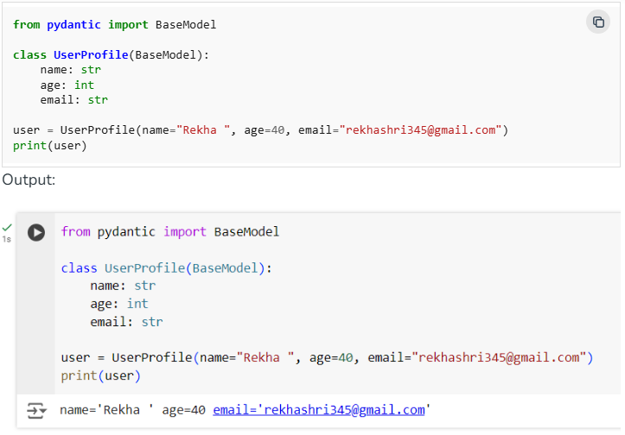

b. Working with Model Attributes
We can access and manipulate the attributes of a Pydantic model just like we would with a regular Python object.
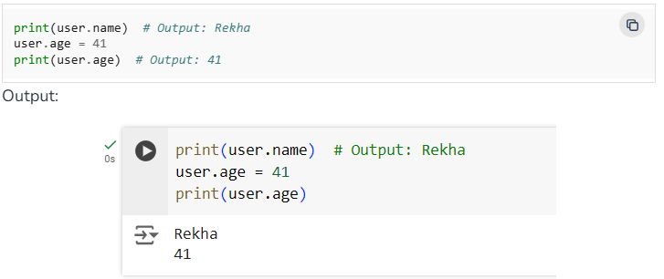

c. Handling Default Values and Required Fields
Pydantic allows us to specify default values for fields, as well as mark certain fields as required.
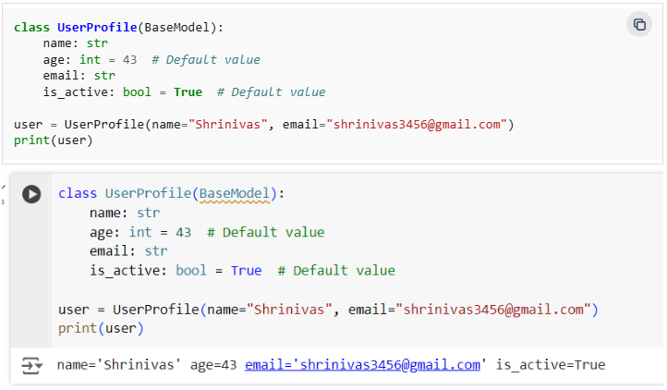
Pydantic offers more advanced validation techniques through decorators and custom validators.

Field Validators (@validator Decorator)
We can create custom validation logic using the @validator decorator.
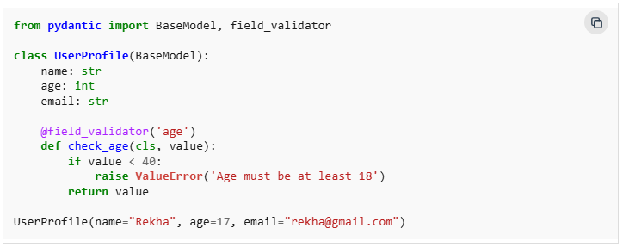
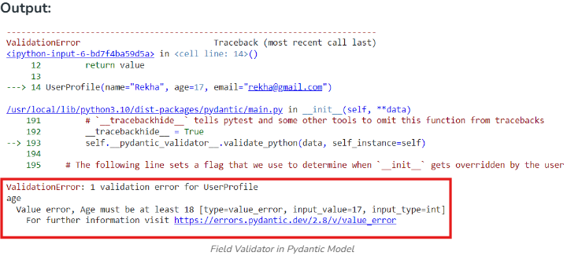
Nested Models and Complex Data Structures
If our data structure is more complex, Pydantic supports nested models.
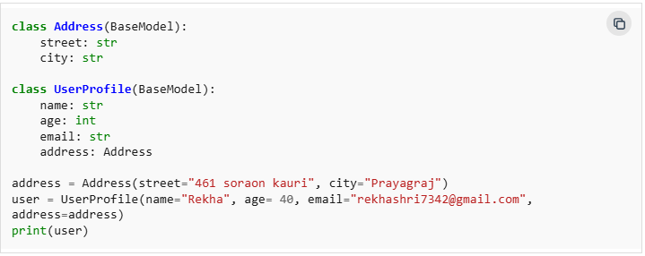
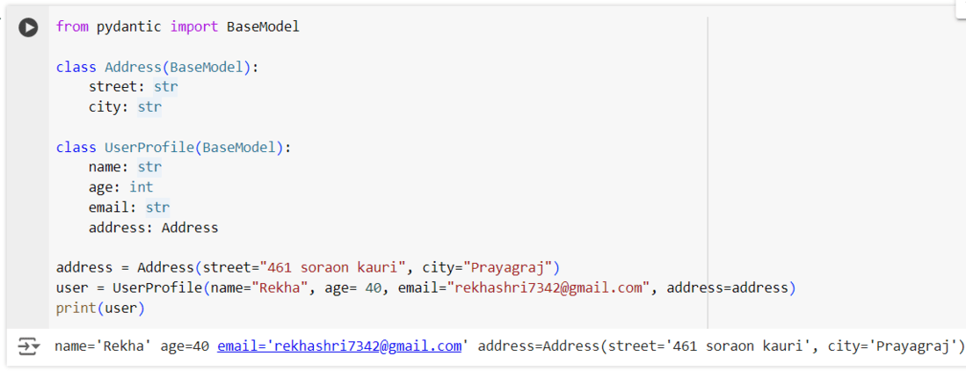
II. Json Output Parser:
- Definition:
JSON stands for JavaScript Object Notation and is a lightweight, text-based data format designed for easy data exchange. JSON is widely used to transmit data between a server and a client as part of a web API response. It is easy to read and write for humans and machines alike, which makes it a preferred choice for data interchange in web applications.

Key Characteristics of JSON

- Text-based: JSON is a simple text format, making it lightweight and easy to transmit.
- Human-readable: It uses key-value pairs, making the structure easy to understand.
- Language-independent: While it is derived from JavaScript, JSON is supported by many programming languages including Python, Java, PHP, and more.
- Data structure: It represents data as objects, arrays, strings, numbers, booleans, and null.
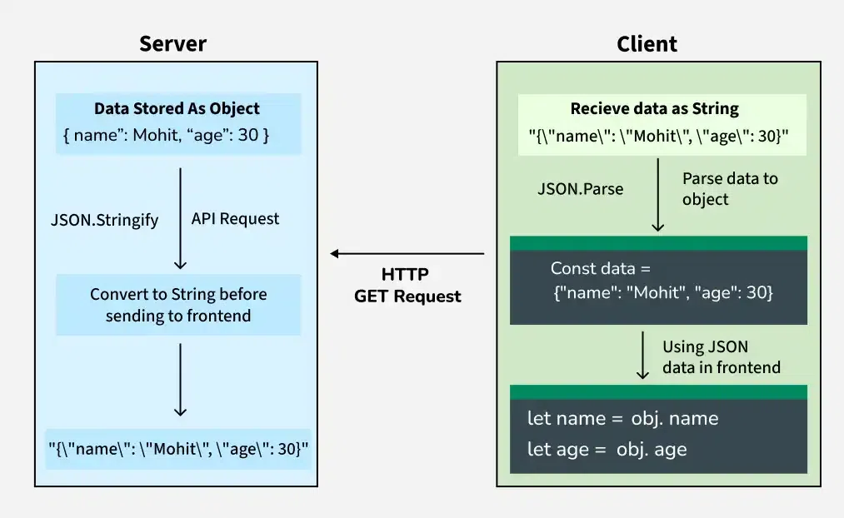

JSON Data Flow: From Server to Client

Parsing Data from JSON and Other Formats

We can parse data directly from JSON strings.
Note: Before running this code, make sure to install pydantic module using this command - pip install pydantic
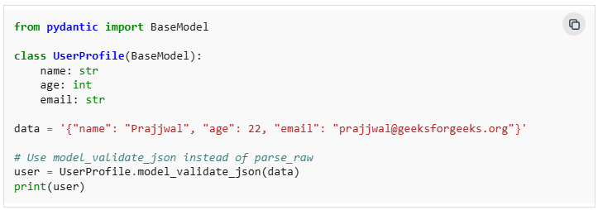
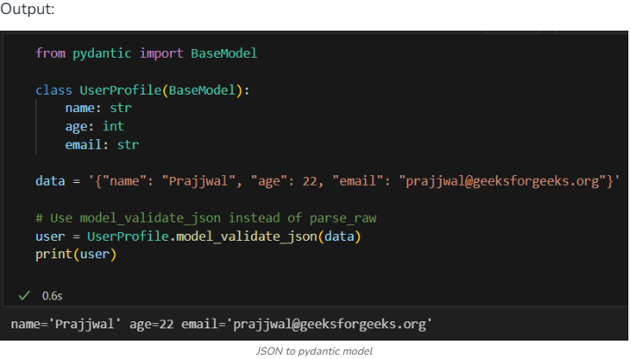

Serializing Models to JSON

Similarly, we can serialize a Pydantic model back to JSON.
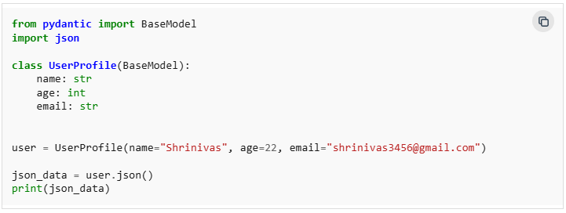

Handling Optional and Nullable Fields

Pydantic supports optional fields using Python's Optional type. The default value for optional fields will be None.
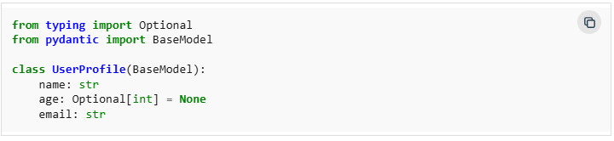
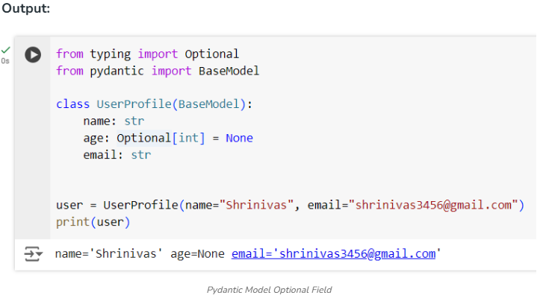

Performance and Optimizations

Using Pydantic’s Cython Extensions for Speed - For performance-critical applications, Pydantic offers optional Cython extensions that significantly improve speed.
Tips for Optimizing Model Performance
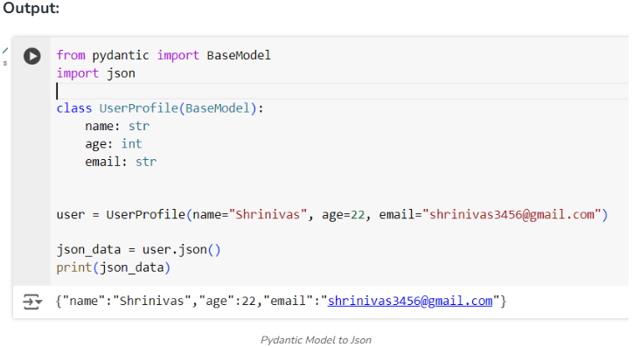
Use validate_all=False: Skip validation for fields without type annotations.
- Leverage @root_validator: Validate the entire model at once to reduce redundant checks.

7. Integrate Pydantic with Other Frameworks
Pydantic can easily be integrated with some popular frameworks such as FastAPI, Django, and Flask.
- Using Pydantic with FastAPI - FastAPI is a modern web framework that uses Pydantic under the hood for data validation.
- Pydantic in Django and Flask Projects - Pydantic can be used alongside Django and Flask to handle data validation in these frameworks.
- Integration with SQLAlchemy and Other ORMs - Pydantic can also be integrated with ORMs like SQLAlchemy for database interactions.

8. Common Use Cases of Pydantic
- API Data Validation and Parsing - Pydantic is widely used in APIs to validate incoming request data and parse it into the correct types.
- Data Processing Pipelines - Pydantic can be used in data processing pipelines to ensure data integrity and consistency across various stages.
- Configuration Management - Pydantic is ideal for managing application configurations, providing type-safe access to configuration data.
Conclusion:
Pydantic is a powerful and flexible library for data validation, parsing, and settings management in Python. Its reliance on type annotations makes it both easy to use and highly efficient, allowing developers to write cleaner, more maintainable code. Whether we're building APIs, processing data, or managing configurations, Pydantic is a valuable tool that can help us ensure our data is always in the correct format.
- Context:
In many real-world applications, we deal with unstructured text — messages, emails, reports, resumes, etc.
However, most systems — such as databases, APIs, or forms — require structured data.
One common way to structure information is by using key-value pairs.
In this section, we will explore how Large Language Models (LLMs) can help us extract key-value pairs from unstructured text.
A key-value pair is a basic data format used to represent structured information.
- Key = the label or field name (e.g., "name")
- Value = the corresponding information (e.g., "Alice")
Example
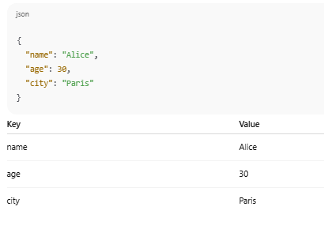
II. Extracting key-value pairs from unstructured text
Key-value extraction, also known as Key Information Extraction (KIE) or structured extraction, involves transforming unstructured text into a structured format, typically key-value pairs. Large Language Models (LLMs) are increasingly being used for this task due to their ability to understand and process natural language effectively.
- How LLMs Facilitate Key-Value Extraction:
- Understanding Context:
LLMs can comprehend the meaning and context of the text, allowing them to identify relevant information and assign it to appropriate keys.
- Handling Variability:
Unlike rule-based systems, LLMs can handle variations in phrasing, formatting, and document layouts, making them robust for diverse data sources like invoices, medical records, or product descriptions.
- Prompt Engineering:
Users can design specific prompts to guide the LLM in extracting desired key-value pairs. For example, a prompt might instruct the LLM to extract "Vendor Name," "Total Amount," and "Invoice ID" from an invoice.
- Few-shot Learning:
LLMs can learn to perform key-value extraction with only a few examples (few-shot learning), reducing the need for extensive labeled training data.
- Handling Unstructured Data:
LLMs excel at processing unstructured data like free-form text, PDFs, or scanned documents, converting them into structured, machine-readable formats.

- Applications:
- Financial Services:
Extracting financial details from bank statements or tax forms for loan processing.
- Healthcare:
Populating Electronic Health Records (EHR) by extracting patient information from medical reports.
- E-commerce:
Extracting product attributes, sentiment, or features from product descriptions and reviews.
- Document Understanding:
Automating the extraction of specific information from various document types like contracts, legal documents, or research papers.

- Considerations:
- Prompt Design:
Effective prompt engineering is crucial for accurate extraction.
- Cost and Efficiency:
While powerful, LLM-based extraction can incur costs, especially with larger models and complex tasks.
- Hallucinations:
LLMs can sometimes generate incorrect or fabricated information, requiring careful validation of extracted data.
- Performance Optimization:
Techniques like self-refinement or fine-tuning can be explored to enhance extraction performance, but their effectiveness and cost implications need to be considered
Example :
From this sentence:
“My name is Alice, I’m 30 years old and I live in Paris.”
We want to extract:
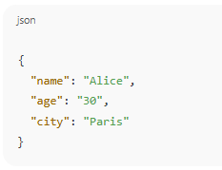
This task requires understanding natural language, not just matching patterns.
- Pattern Matching vs. Language Understanding

a . Pattern Matching (e.g., Regex)
Pattern matching looks for specific formats (like "Age: 30") without truly understanding the text.
Example: text
Name: Alice
Age: 30
Easy for regex to extract:
- Name: followed by a word
- Age: followed by a number
But…
b. Natural Language Understanding (NLP)
People often use free and varied language that doesn't follow a strict pattern.
Example 1: text
Hey, I'm Alice. Just turned 30 this year. Living in Paris since 2020.
Example 2: text
They call me Sami. I'm from Tunis and will be 37 next month.
These require:
- Understanding synonyms (e.g., “turned 30” means age = 30)
- Inferring meaning (“will be 37 next month” → age = 36 or 37)
- Identifying entities without clear labels
- Disambiguating context (is the number a phone, an age, or something else?)

Why LLMs are better for this:
LLMs like GPT or Claude are trained on massive natural language data, so they:
- Understand various ways of expressing the same fact
- Detect implied meanings
- Can extract information even if the format is unusual or informal

Summary:
Pattern Matching = rigid rules, fragile formats
Natural Language Understanding = flexible, context-aware, human-like extraction
Text | Pattern Matching | LLM
"I just turned 30" | NAN | age = 30
"Call me at 98 123 456" | NAN | phone = 98 123 456
"I live in the capital of Tunisia" | ❌ | city = Tunis
Example – Prompt and Output
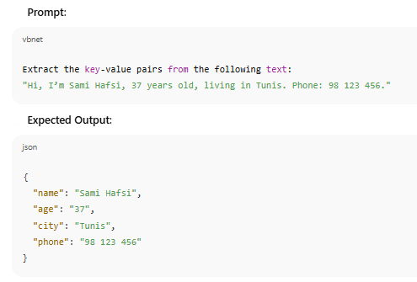

Applications: Feeding Outputs into ML Pipelines
Once unstructured text is parsed and validated with JsonOutputParser and Pydantic, the resulting structured data can be seamlessly integrated into machine learning pipelines. This step is crucial because ML models require clean, consistent, and well-formatted inputs to produce reliable predictions.
Structured outputs fit into different stages of a ML workflow:
- Data Preprocessing & Feature Engineering
  - Convert extracted key-value pairs into numerical or categorical features.
  - Example: From a customer feedback sentence like
"The delivery was late by 3 days and the package was damaged"
→ Extract fields: {"delay_days": 3, "package_condition": "damaged"}
→ Encode for ML: delay_days = 3, package_condition = 1.
- Model Input Preparation
  - Ensure the data format exactly matches the ML model’s expected schema.
  - Example: Feeding validated date, location, and amount fields into a time-series forecasting model without missing values or incorrect formats.
- Automated Decision Systems
  - Use structured data directly in real-time decision-making.
  - Example: Fraud detection system receives extracted transaction details from a chatbot interaction and triggers an alert if values meet risk criteria.
- Training & Evaluation
  - Feed extracted and validated datasets into ML training pipelines to build predictive models.
  - Example: Use structured medical notes to train a model predicting patient readmission risk.
- Model Deployment & Monitoring
  - Continuously feed real-time structured outputs into deployed models for predictions.
  - Example: Live customer support data is parsed and immediately used to predict customer churn probability.
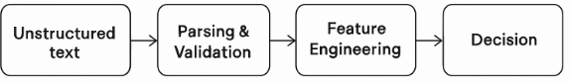
Key Benefit:
By ensuring that all incoming text data is parsed, validated, and structured, we eliminate the risk of pipeline failures, improve model accuracy, and enable smooth automation from raw text to actionable ML insights.

What You're Aiming For
Transform a collection of raw, unstructured documents into structured metadata that can be validated and used in downstream processes.

Instructions

- Input: Batch of Unstructured Documents
  - Example: PDFs, text files, scanned reports, or raw HTML pages.
- Parsing & Key-Value Extraction
  - Use LLMs + JsonOutputParser to extract relevant metadata fields.
  - Example fields:
    - title
    - author
    - publication_date
    - keywords
    - document_type
- Validation with Pydantic
  - Create a Pydantic model defining expected data types and constraints.
  - Automatically reject or flag entries that don’t match the schema (e.g., wrong date format).
- Output: Clean, Structured Dataset
  - Export as JSON, CSV, or insert directly into a database.
  - Ready for analytics, search indexing, or ML model training.
Example:
Unstructured text → Extract (title, author, date, keywords) → Validate → Save as structured JSON dataset.
from langchain.prompts import PromptTemplate
from langchain.output_parsers import JsonOutputParser
from pydantic import BaseModel, Field
from langchain.chat_models import ChatOpenAI

class DocumentMetadata(BaseModel):
title: str = Field(..., description="Title of the document")
author: str = Field(..., description="Author of the document")
publication_date: str = Field(..., description="Date in YYYY-MM-DD format")
keywords: list[str] = Field(..., description="List of keywords")
document_type: str = Field(..., description="Type of the document, e.g., report, article")

parser = JsonOutputParser(pydantic_object=DocumentMetadata)

prompt = PromptTemplate(
template="""
Extract the following metadata from the document text:
title, author, publication_date, keywords, and document_type.

Return the result in JSON strictly matching this schema:
{format_instructions}

Document text:
{document_text}
""",
input_variables=["document_text"],
partial_variables={"format_instructions": parser.get_format_instructions()}
)

model = ChatOpenAI(model="gpt-4o-mini", temperature=0)

documents = [
"""This report, 'AI Trends 2025', was written by Dr. Sarah Lee and published on 2025-05-01.
It covers topics like artificial intelligence, deep learning, and ethics in AI.""",
"""The article 'Climate Change and Agriculture' by John Smith was released on 2024-09-15.
It discusses sustainability, farming practices, and environmental policy."""
]

structured_metadata = []
for doc in documents:
prompt_text = prompt.format(document_text=doc)
response = model.invoke(prompt_text)
metadata = parser.parse(response.content)
structured_metadata.append(metadata.dict())
for idx, data in enumerate(structured_metadata, start=1):
print(f"Document {idx} metadata:")
print(data)

What this script does:
- Pydantic Model – Defines the expected structure and validates the fields (types, formats).
- JsonOutputParser – Forces the LLM to return a well-formed JSON output.
- PromptTemplate – Guides the AI to extract exactly the required fields.
- Loop over documents – Processes a batch of texts in a single script.
- Final result – A clean list of dictionaries, ready for storage or machine learning tasks.

